Jefferson Soil & Water Conservation District Scholarship
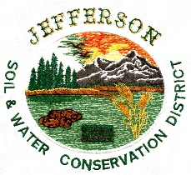

210 South 5th West, Rigby, ID 83442, 208 754-3210

For the 2025 graduating class from Jefferson County Idaho High Schools, the Jefferson Soil and Water Conservation District will fund $1,000.00 scholarships. Criteria for selection is based on students pursuing study in an agriculture or natural resources related field.

Recipients will be selected by the Board Supervisors at a JSWCD board meeting. The application deadline is February 12, 2025. A check from the Conservation District office will be given to each selected student after the student registers for the second semester of study at the school of their choice. The student will provide a transcript for the first semester and proof of registration for a second semester. The scholarship will expire 3 years from the date of graduation.

Name: _____________________________________________________________________________

Address: ___________________________________________________________________________

Cell: ______________________ E mail: __________________________________________________

Birthday: _____________________________ Graduation Year: ________________ GPA: _________

Parent or Guardian Name and Phone Number: ____________________________________________

College(s) Applicant plans to attend: ____________________________________________________

High School Extracurricular Activities: ___________________________________________________

_____________________________________________________________________________________

_______________________________________________________________________________________

Career Goals in agriculture/ natural resources: _______________________________________________

_______________________________________________________________________________________

Student must include a short essay of a typed, double-spaced, single page explaining their planned course of study, the school(s) that they would like to attend, and their career goals following graduation from said college(s). Please include full name on the essay.

Submit this application and one-page essay to the Jefferson SWCD office by 4 pm, February 12, 2025. Jefferson SWCD is located at 210 S 5th W, Rigby Idaho 83442. Questions can be answered at 208-754-3210.

